Case Study: Brightlearn Coffee Shop
Submission: 07 Aug 2026
Methodology
1. Define Objectives
- The intention of the case study is to identify product category performance?
- Comparison across product categories?
- What trends can be found per store branch of Brightlearn Coffee Shop?
- The performance of the product category in the lowest revenue store branch?
- Insights on the top performing products sold?
- What is the time interval overview of the total revenue per each store branch?
- Identify the trend throughout the week of the store branch that records the lowest total revenue
- Which month records the highest /lowest total revenue for coffee sold?
2. Data Collection
- Used the provided pivot tables and turned data into charts (coffee, tea, bakery, revenue by product).
- Ensure data is clean: check for duplicates, blanks, or inconsistent naming (e.g., “Rg” vs “Regular”).
3. Data Preparation
- Correct unit price column value from string into integer
- Aggregate totals by product type and by size.
4. Analysis Techniques
- Descriptive Analysis:
  - Find top-selling products (e.g., Columbian Medium Roast Lg).
  - Identify underperforming items (e.g., Ouro Brasileiro shot).
- Comparative Analysis:
  - Compare coffee vs. tea vs. bakery sales.
  - Compare revenue vs. units sold to see profitability.
- Trend Visualization:
  - Use line graphs to show sales distribution across coffee types.
5. Visualization
- Line Graphs:
  - Coffee types on the x-axis, products sold on the y-axis.
- Bar Charts:
  - Compare categories (coffee, tea, bakery).
- Pie Charts:
  - Show percentage contribution of each product category to total sales.
6. Interpretation
- Highlight key findings:
  - Coffee dominates overall sales.
  - Identify which branch performs the best.
  - Certain products (e.g., Barista Espresso, Hot Chocolate) drive revenue more than volume.
- Discuss customer preferences and possible marketing strategies/ product pairing.
7. Recommendations
- Promote high-performing products (Columbian Medium Roast, Latte).
- Reassess low performers (Ouro Brasileiro shot, Green beans).
- Consider bundling bakery items with coffee to boost cross-sales.
- Use insights to guide inventory, pricing, and promotions.

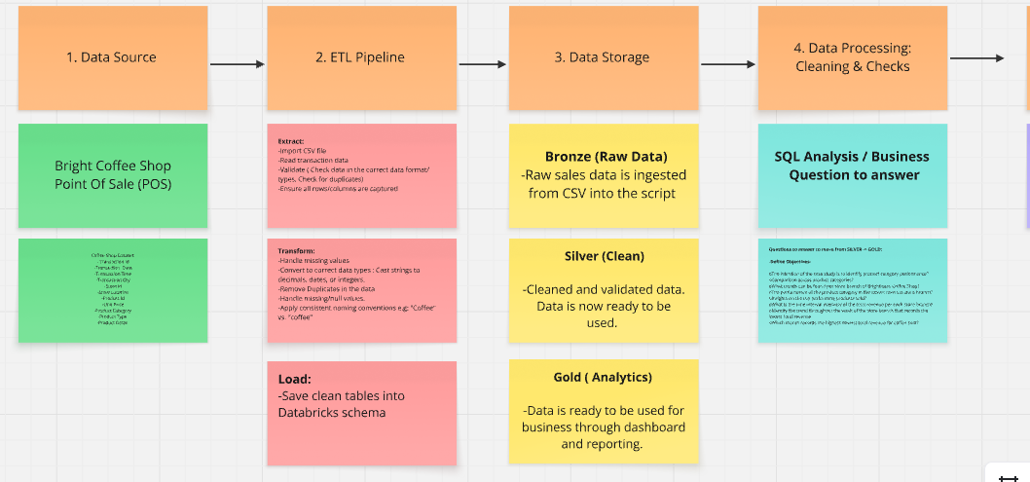
Planning & Architecture (Miro)

